Computer Systems Security Laboratory Report 3

Objectives:

* To test spoofing using tcpdump commands
* To understand the security Triads(Confidentiality, Integrity and Availability)

Lab Setup:

Operating System

* Host Machine: Windows 10 Pro
* Virtualization Software: Oracle VM VirtualBox 7.0.14
* Operating System simulator :Kali Linux

Methodology

Kali Linx is already virtualized on oracle VB.We used it for checking some tcpdump related commands on terminal to analyze packets coming and going out through the interfaces.We opened browser on kali and opened some random site to generate packet flow.

Challenges Faced

Problem: Inability to browse the internet through kali’s browser

Solution: Changing the adapter type in oracle settings for kali into paravirtualized network.

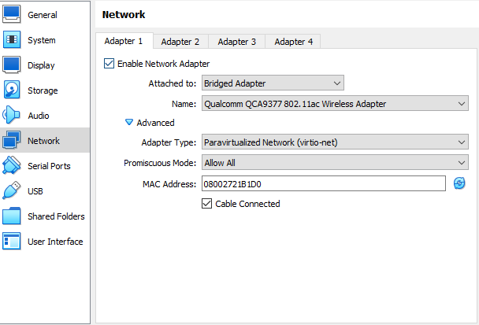

Results

-Packet analysis by filtering and customizing using some options on `tcpdump`

Report prepared by:

1. Ananiya H/meskel

2. Barnabas Solomon

3. Dagmawi Aschalew